Chapter 13: Problems and Applications
- a)
- FLEXIBLE EXCHANGE RATE:
IS* will shift to the left reducing e. There will be no effect on GDP. The trade balance will increase. In the loanable funds' framework NX=S-I. Since S is higher, S-I has increased, and so has NX.
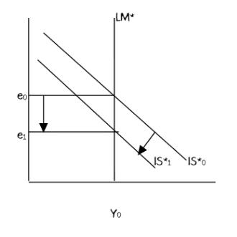
- FIXED EXCHANGE RATE:
A fall in consumer confidence will shift IS* to the left, pushing e down. To keep e fixed, monetary authorities will sell foreign currency and buy a domestic currency, which in turn will reduce money supply shifting LM * to the left. The output will fall, but there will be no change in net exports or trade balance.
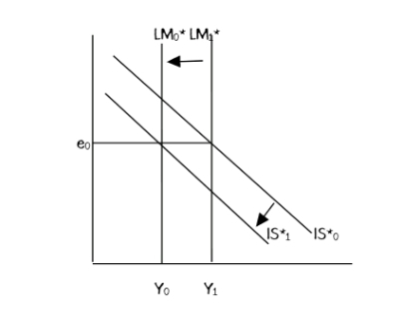
b) The introduction of a stylish line of Toyotas makes some consumers prefer foreign cars over domestic cars.
FLEXIBLE EXCHANGE RATE: The graph for this will be similar to (a). Net exports will drop, causing a leftward shift in the IS* curve. The output does not change while the exchange rate falls. The fall in e will increase net exports, and the trade balance will, however, be unchanged. (In the new equilibrium since NX=S-I and both S and I are unchanged.)

FIXED EXCHANGE RATE: The graph for this will also be similar to the fixed exchange rate system in (a). To prevent the currency from depreciating, the domestic monetary authorities will sell foreign currency, which in turn will decrease the money supply. This will shift LM* to the left. Y will fall. NX will be lower also.
c. The introduction of automatic teller machines reduces the demand for money.
Under floating XR: This would shift the LM* to the right, causing a depreciation and an increase in Y. At higher Y, there is more S, which moves S-I to the right.
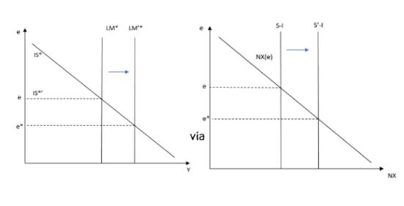
Under fixed XR: As a result, under a fixed exchange rate regime, the decrease in money demand would reduce reserves but would leave Y unaffected.

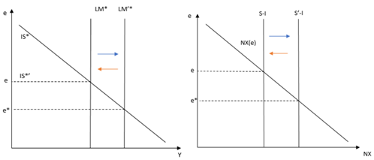
- A small open economy with a floating exchange rate is in recession with balanced trade. If policymakers want to reach full employment while maintaining fair trade, what combination of monetary and fiscal policy should they choose? Use a graph, and be sure to identify the effects of each policy.
Let us say that Y* is the full employment level of output. To move the economy from Y0 to Y*, an expansionary fiscal policy or an expansionary can be used. An expansionary fiscal policy by itself will appreciate the domestic currency causing trade balance to decrease. At the same time, an expansionary monetary policy by itself will depreciate the domestic currency, causing the trade balance to increase. To maintain the trade balanced, a combination of expansionary fiscal and monetary policies that will keep e unchanged should be used, which will move the economy to point B and raise output to Y*.

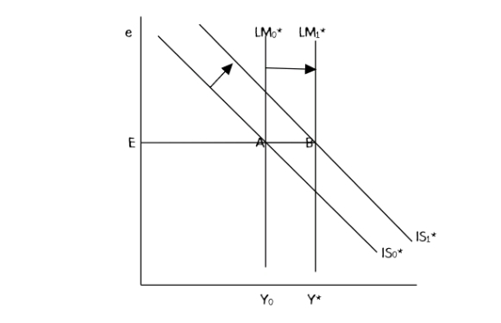
3. The Mundell–Fleming model takes the world interest rate r ∗ as an exogenous variable. Let’s consider what happens when this variable changes.
a. What might cause the world interest rate to rise? (Hint: The world is a closed economy.)
An increase in world demand for loanable funds (world investment demand) or a decrease in the world supply of loanable funds (For instance, an increase in fiscal spending by the rest of the world) can cause r* to rise.
b. In the Mundell–Fleming model with a floating exchange rate, what happens to aggregate income, the exchange rate, and the trade balance when the world interest rate rises?
LM,* will shift to the right while IS* will shift to the left (I is a function of r*). Aggregate income will rise, the domestic currency will depreciate, and the trade balance will increase.
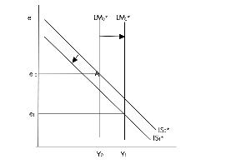
c. In the Mundell–Fleming model with a fixed exchange rate, what happens to aggregate income, the exchange rate, and the trade balance when the world interest rate rises?
With a fixed exchange rate. The monetary authorities will sell foreign currency and buy the domestic currency to which will shift LM1* to LM2*. The output will fall to Y2, exchange rate and trade balance will be unchanged.
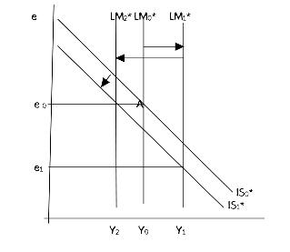
- Business executives and policymakers are often concerned about the competitiveness of American industry (the ability of U.S. industries to sell their goods profitably in world markets).
- How would a change in the nominal exchange rate affect competitiveness in the short run when prices are sticky?
In this case, we find that the exchange rate increases because the domestic money also increases. The domestic price and (ep*) are relatively high, meaning that the domestic firms are less competitive. A depreciation of the exchange rate would result in lower domestic prices, and it will increase the competitiveness of goods.
- Suppose you wanted to make domestic industries more competitive but did not want to alter aggregate income. According to the Mundell–Fleming model, what combination of monetary and fiscal policies should you pursue? Use a graph, and be sure to identify the effects of each policy.
To make domestic industries more competitive, the exchange rate must be lower as there must be a depreciation of the domestic currency. Thus under a floating exchange rate regime, the monetary authority in the central bank must increase the supply of money to shift the LM to the right; as a result, the interest rate falls, which implies that the value of funds (domestic currency) falls. Alternatively, the government reduces its expenditure by the same amount by decreasing the G and IS curve moves leftwards. There will be an increase in exports equivalent to the amount of reduced government expenditure.

E

L M₁
E₁
e₁ L M₂

e₂ E₂ I S₁
I S₂

Yy
5. Suppose that higher-income implies higher imports and thus lower net exports. That is, the net-exports function is NX = NX (e, Y). Examine the effects in a small open economy of fiscal expansion on income and the trade balance under the following exchange-rate regimes.
a. A floating exchange rate
In this case, when the economy is pursuing a floating exchange rate regime, the market determines the exchange rate based on the demand and the supply of both domestic and foreign currency. In the small open economy, the fiscal expansion caused as a result of the increase of government expenditure or reduced tax causing the IS curve to shift upwards. In the small open economy, the LM curve is vertical because it is independent of the change in output. The changes in the exchange rate do not affect the LM curve; thus, no effect on output and income.
- A fixed exchange rate how does your answer compare to the results in Table 13-1
In a fixed exchange rate, the fiscal expansion causes the IS to move to the right. The upward movement of the IS curve causes an increase in the exchange rate but maintains the original exchange rate. Therefore, the central bank intervenes in the exchange market by purchasing foreign and selling dollars. In the process, there is an increase in the supply of money in the market, causing the LM to move to the right. The output increases.
- Suppose that money demand depends on disposable income so that the equation for the money market becomes M/P = L(r, Y − T). Analyze the short-run impact of a tax cut in a small open economy on the exchange rate and income under both floating and fixed exchange rates.
The tax-cut multiplier is MPC/1-MPC; it will increase income so that Y-T will increase. If r is constant, M/P will increase. An increase in the money supply reduces the value of the exchange rate, given the interest rate.
7. Suppose that the price level relevant for money demand includes the price of imported goods and that the price of imported goods depends on the exchange rate. That is, the money market is described by M/P = L(r, Y), where P = Pd + (1 − )Pf /e. Here, Pd is the price of domestic goods, Pf is the price of foreign goods measured in the foreign currency, and e is the exchange rate. Thus, Pf /e is the price of foreign goods measured in the domestic currency. The parameter is the share of domestic goods in the price index P. Assume that the price of domestic goods Pd and the price of foreign goods measured in foreign currency Pf are sticky in the short run.
a. Suppose that we graph the LM ∗ curve for the given values of Pd and Pf (instead of the usual P). Is this LM ∗ curve still vertical? Explain.
The LM curve moves upwards. A higher exchange rate indicates that foreign good is cheaper, and they will be consumed more. This causes lower prices, which is favorable for the money market. At this point, of low prices, the real balance goes high; thus, the increases in income and money demand helps to maintain an equilibrium point in the money market.
- What is the effect of expansionary fiscal policy under floating exchange rates in this model? Explain. Contrast with the standard Mundell–Fleming model.
Regarding the Mundell- Fleming model, the expansionary fiscal policy does not affect output and the floating exchange rate.
8. Use the Mundell–Fleming model to answer the following questions about the state of California (a small open economy).
a. What kind of exchange-rate system does California have with its major trading partners (Alabama, Alaska, Arizona . . .)?
A fixed exchange rate system
- If California suffers from a recession, should the state government use monetary or fiscal policy to stimulate employment? Explain. (Note: For this question, assume that the state government can print dollar bills.)
The government of California can use fiscal policy to foster employment because of the fixed exchange rate, and it does not use monetary policy.
- If California prohibited the import of wines from the state of Washington, what would happen to income, the exchange rate, and the trade balance? Consider both the short-run and the long-run impacts.
If the government of Californian buns the importation of wines from Washington, the net exports will move rightwards, causing a shift of the IS curve to the right. The trade balance and income will increase without interfering with the exchange rate in the short run. The increase in demand and prices occurs in the long run. The rise in prices reduces the supply of money. The real exchange rate will go up, affecting trade balance and income.
- Can you think of any important features of the Californian economy that are different from, say, the Canadian economy and that might make the Mundell–Fleming model less useful when applied to California than to Canada?
California uses the U.S dollar, yet Canada uses the Canadian dollar. The fiscal and monetary policies are more functional in Canada than in California. In this case, the Mundell Fleming model is not useful when applied to Californians Canada.

